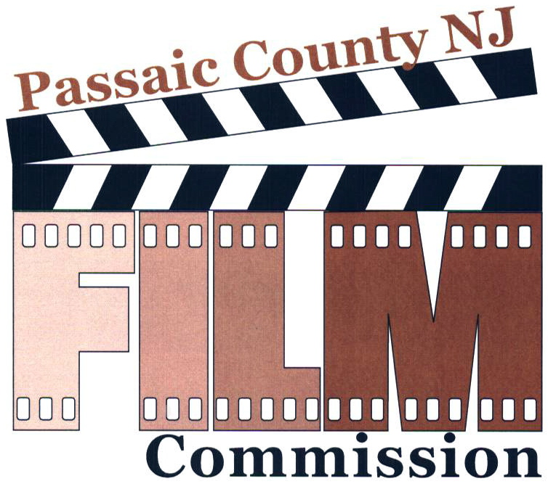
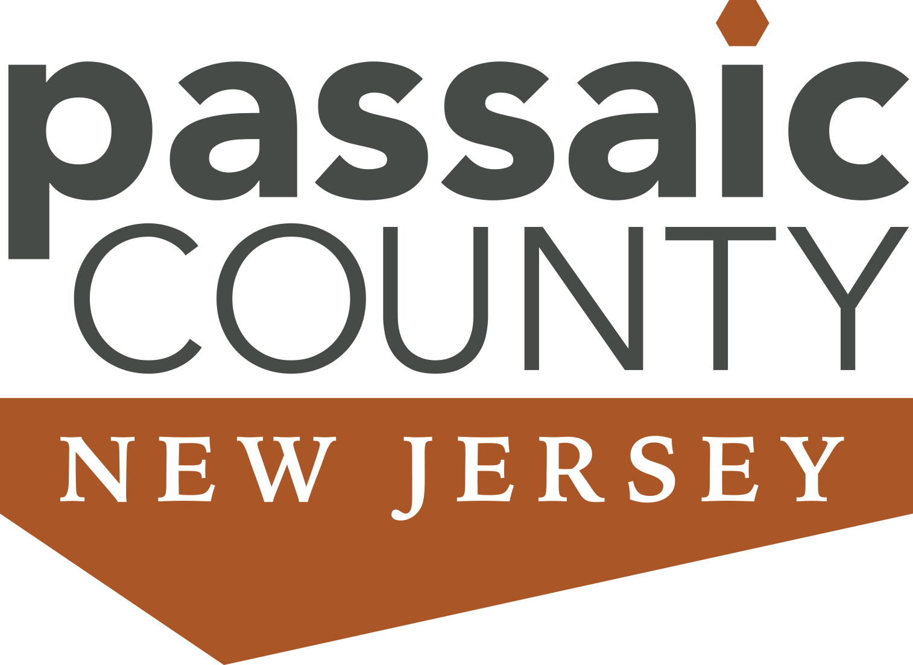

Passaic County Film Festival 2025

Call for Entries - Entry Form

DEADLINE FOR ENTRIES:
February 3, 2025 by 4:00 PM
FESTIVAL SCREENING DATE AND LOCATION:

April 26, 2025
11:00 am

Location:
Passaic County Community College
Public Safety Academy
300 Oldham Road
Wayne, NJ

The Passaic County Film Festival is sponsored by:

The Passaic County Board of County Commissioners

John W. Bartlett, Esq.
County Commissioner Director
Cassandra “Sandi” Lazzara
County Commissioner Deputy Director
Orlando Cruz
Terry Duffy
Nicolino Gallo
Bruce James
Pat Lepore

Passaic County Film Festival 2025

Call for Entries- Entry Application Form
OVERVIEW: This is the 21st year of the Passaic County Film Festival, a juried exhibition of student and independent filmmakers' work. The Festival will showcase a wide range of film projects created by students and independent filmmakers who live, attend school, or work in Passaic County.
OBJECTIVE: The objective of the Film Festival is to support student and independent film makers by providing a public forum in which to showcase their work and provide an opportunity to interact with members of the television and filmmaking community.
FILM ENTRY CRITERIA: All entries must be the sole creative and technical effort of the individual(s) submitting the work. Films must be produced, directed, edited, etc. by High School Students, University Students or Independent Filmmakers only.
Film entries must be no more than 10 minutes in length. Public Service Announcements have a time limit of 90 seconds. The following film categories apply: 1. General Short Film; 2. Animation; 3. Public Service Announcement; 4. Documentary; and 5. Music Video and Performance. There will be one Grand Prize awarded for the best film of the Festival.
Entries will only be accepted from individuals who are enrolled in an educational institution in Passaic County, who live in Passaic County, who work in Passaic County, or a film that was filmed in Passaic County and will not be returned. No films will be judged if they are submitted from the members of the Passaic County Film Commission or their immediate family, however, films may be screened at the festival. Films previously submitted to the Passaic County Film Festival will not be considered. The members of the Film Commission reserve the right to combine categories or re-categorize a film entry.
Please note that the Passaic County Film Festival will accept films that adhere to the Motion Picture Association of America Ratings Board, Rating System for the following ratings: General Audience, Parental Guidance Suggested and PG-13 Parents Strongly Cautioned. Some Material May be Inappropriate for Children under 13. Please note the attached description of these three ratings. Any film containing R-rated material, nudity, graphic violence, or in the exclusive opinion of the Passaic County Film Festival Commission glamorizes drug use or drug references, or alcohol or cigarette consumption or illegal activities will not be accepted for screening.
THERE IS NO ENTRY FEE FOR THIS FESTIVAL.
ADMISSION TO THE FESTIVAL ON APRIL 26, 2025 IS ALSO FREE.
DEADLINE FOR ENTRIES: February 3, 2025 by 4:00 PM
FESTIVAL SCREENING DATE AND LOCATION: April 26, 2025, 11: 00 am, Passaic County Community College, Public Safety Academy, 300 Oldham Road, Wayne, NJ and YouTube
Page 1
Passaic County Film Festival
Acceptable Rating System for All Films

G: GENERAL AUDIENCES – All Ages Admitted. A G-rated motion picture contains nothing in theme, language, nudity, sex, violence or other matters that, in the view of the Film Commissioners, would offend parents whose younger children view the motion picture. Some snippets of language may go beyond polite conversation, but they are common everyday expressions. No stronger words are present in G-rated motion pictures. Depictions of violence are minimal. No nudity, sex scene or drug-use is present in the motion picture.
PG: PARENTAL GUIDANCE SUGGESTED – Some Material May Not Be Suitable for Children. The PG rating indicates, in the view of the Film Commissioners, that parents may consider some material unsuitable for their children. The more mature themes in some PG-rated motion pictures may call for parental guidance. There may be some profanity and some depictions of violence or brief nudity. But these elements are not deemed so intense as to require that parents be strongly cautioned beyond the suggestion of parental guidance. There is no drug use content in a PG-rated motion picture.
PG-13 – Parents Strongly Cautioned. Some Material May Be Inappropriate for Children Under 13. A PG-13 motion picture may go beyond the PG rating in theme, violence, nudity, sensuality, language, adult activities or other elements, but does not reach the restricted R category. Any drug use will initially require at least a PG-13 rating. More than brief nudity will require at least a PG-13 rating, but such nudity in a PG-13 rated motion picture generally will not be sexually oriented. There may be depictions of violence in a PG-13 movie, but generally not both realistic and extreme or persistent violence. A motion picture’s single use of one of the harsher sexually derived words, though only as an expletive, initially requires at least a PG-13 rating. More than one such expletive requires an R rating, as must even one of those words used in a sexual context. The Film Commissioners may rate a motion picture PG –13 if the context or manner in which the words are used, or because the use of those words in the motion picture, is inconspicuous.

Page 2

METHOD OF EVALUATION: All entries will be screened and evaluated by the members of the Passaic County Film Commission. The following film categories apply: 1. General Short Film; 2. Animation; 3. Public Service Announcement; 4. Documentary; and 5. Music Video and Performance. There will be one Grand Prize awarded for the best film of the Festival. A minimum of 5 films must be received per category in order to be judged within that category. If fewer than 5 films per category are received, the films will be judged within the General Short Film category. The Grand Prize will be selected from the first-place winning films in each category entered in the Festival. The members of the Film Commission reserve the right to combine categories or re-categorize a film entry. Only one physical award will be presented for each winning film.
AWARDS:
The Passaic County Film Festival Award – The Costello – will be awarded to the first, second, and third place winners from the High School Student entries (class); and the first, second, and third place winners from the University Student and/or Independent Filmmaker entries (class). The highest ranked entries in each Class (High School Students, University Students and/or Independent Filmmakers) selected by the judges will be provided an opportunity to be screened at the Festival.

One Grand Prize for the best film of the Festival will be selected from all first-place winning films in each category and will also be awarded The Costello. The Grand Prize film will be evaluated by the quality of its story telling and film making techniques. Grand Prize films will be ranked 1-5 with 5 representing the highest score.
EVALUATION CRITERIA: Each film will be evaluated utilizing the following criteria:
Scriptwriting (Creativity, Originality, and Structure): 10 points
Cinematography (Camera work, lighting quality): 10 points
Audio: (Recording, editing and mixing of audio, music): 10 points
Editing: (Editing and Postproduction including Special Effects): 10 points
Onscreen Performance of Actors: 10 points (Performances will not be judged in Documentaries)
Reporting/Research: 10 points (Documentary Films only)

The highest score a film can receive is 50 points. The film with the highest score in each Category and Class will be declared the first-place winner. The film with the second highest score in each Category and Class will be declared the second-place winner. The film with the third highest score in each Category and Class will be declared the third-place winner.

ENTRY INSTRUCTIONS:
Please forward all entries with an accompanying completed and signed entry form to:
passaiccountyfilmcommission@gmail.com

For additional information contact our office at: 973-569-4720

A pdf version of the film festival application is available at: www.passaiccountynj.org or https://www.passaiccountynj.org/government/boards-committees-and-commissions-f-z/film-commission

Page 3

FILM WORKSHOP: The Passaic County Film Commission will not be offering an in-person Film Workshop in 2024. Information that supports filmmaking can be found at the following links:
      - Passaic County Film Commission Helpful Sites
      - Top 10 Rules for Video Editing
      - Scriptwriting
      - Promoting and Distributing
      - Standard Release Forms
      - Scheduling
      - Designing a Movie for Sound
      - Good Sound from Amateur Video Cameras
      - Sample Forms
      - The Art of Story Board
      - Sound Notes

The above information can also be found at our website: https://www.passaiccountynj.org/government/boards-committees-and-commissions-f-z/film-commission/passaic-county-film-festival/film-festival-workshop.

Or


Page 4

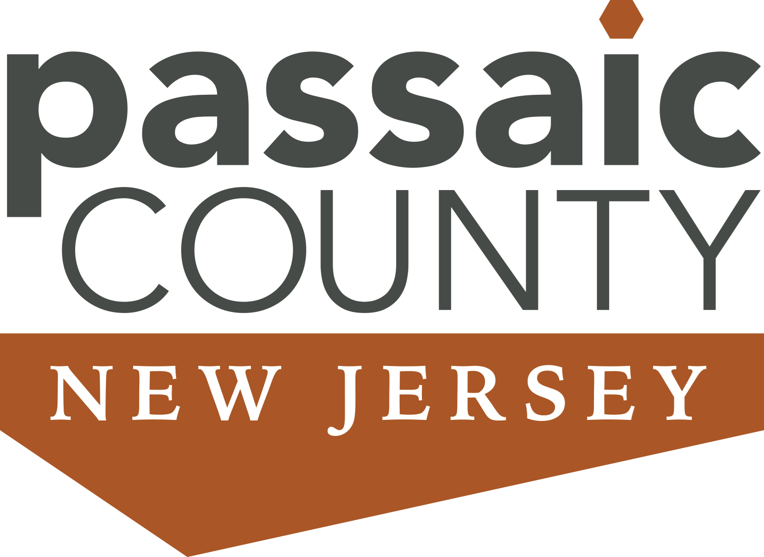

Passaic County Film Festival 2025

Entry Number: ________

(For Office Use Only)

ENTRY APPLICATION FORM

Title of Short Film: ______________________________________________________________
Contact Information: Please print clearly since email is our primary means of communication.
Name of Filmmaker | Email Address
Primary Filmmaker Address: ____________________________________________
City, State, Zip Code: _________________________________________________
Telephone: _________________________________________________________
Film Category (select one)

❒ General Short Film  Animation  Public Service Announcement
❒ Documentary Film  Music Video and Performance

Student Class and School Information

❒ High School: Grade: ______  College: Grade: _______
Teacher
Name of Teacher: ______________________________Email: ____________________________
Name of School: ________________________________________________________________

School Address and Telephone Number: ____________________________________________
_______________________________________________________________________________

Independent Filmmaker

❒ Independent Filmmaker
❒ Film Commissioner: film will not be judged, but considered for screening
Page 1

Passaic County Film Festival 2025

Short Film Information
Title of Short Film: ____________________________________________________________
Please upload your film on our Google Drive: passaiccountyfilmcommission@gmail.com
The Format of the short film must be in the following digital format: MPEG4

Please do not use copy protection on your submissions. Copy protected material cannot be technically processed to screen at the festival. The title of the film on the electronic file must match the title of the film on the application in order to avoid confusion. A unique title for your film is appreciated.
Date Film Completed: ________________________ Length of film: ___________ minutes
Briefly describe the story line of your short film: _________________________________________________________________
Did you use AI software to create your film? ________________________________________

How did you learn about the Film Festival? _________________________________________________________________

INDEMNIFICATION (All filmmakers listed on Page 1 must complete this section, please
make additional copies if necessary.)
I /We will indemnify and hold harmless Passaic County, NJ, the Passaic County Film Festival, its sponsors, and partners individually and collectively, from and against all claims, demands, losses, damages, costs, liabilities, and expenses, including legal expenses arising out of or in connection with any and all claims, or third-party claims, based on material submitted to Passaic County Film Festival.
Passaic County hereby has my permission to use my name, my film, photos, and press materials for pre- or post-festival promotion which may include placement on the Passaic County website, Passaic County Facebook page, Passaic County Fair, Cablevision, YouTube and other local stations, in print media and on social media. I/We understand that no entries will be returned to the filmmaker.
By signing this form, I/we understand and agree to all the terms and conditions of the Passaic County Film Festival.
Signatures and Date:

___________________________________________________________________________
Filmmaker Signature Print Name Date

___________________________________________________________________________
Parent or Guardian Signature Print Name Date
(If the filmmaker is under 18 years of age, please provide a signature by a parent or guardian)

If you have any questions on this application or on the Film Festival, please contact The Passaic County Film
Commission at (973) 569-4720 or e-mail Keeurly Reyes: KReyes@passaiccountynj.org.
Return all applications to: Passaic County Department of Planning and Economic Development
Division of Economic Development, 401 Grand Street, Paterson, NJ 07505, Room 417; deborahh@passaiccountynj.org
Page 2

